

APPLICATION FORM FOR ENVIRONMENTAL AUTHORISATION

(For official use only)
File Reference Number:
NEAS Reference Number:
Date Received:

Application for authorisation in terms of the National Environmental Management Act, 1998 (Act No. 107 of 1998), (the Act) and the Environmental Impact Assessment Regulations, 2014 the Regulations)

PROJECT TITLE
Eskom Northern KwaZulu-Natal Strengthening (Iphiva-Duma 400 kV Powerline)
DEA REF NO. 14/12/16/3/3/2/1038

Kindly note that:

- This application form is current as of 08 December 2014. It is the responsibility of the applicant to ascertain whether subsequent versions of the form have been published or produced by the competent authority.

- The application must be typed within the spaces provided in the form. The sizes of the spaces provided are not necessarily indicative of the amount of information to be provided. Spaces are provided in tabular format and will extend automatically when each space is filled with typing.

- Where applicable black out the boxes that are not applicable in the form.

- The use of the phrase “not applicable” in the form must be done with circumspection. Should it be done in respect of material information required by the competent authority for assessing the application, it may result in the rejection of the application as provided for in the Regulations.

- This application must be handed in at the offices of the relevant competent authority as determined by the Act and Regulations.

- No faxed or e-mailed applications will be accepted. An electronic copy of the signed application form must be submitted together with two hardcopies (one of which must contain the original signatures).

- Unless protected by law, all information filled in on this application form will become public information on receipt by the competent authority. Any interested and affected party should and shall be provided with the information contained in this application on request, during any stage of the application process.

- Should a specialist report or report on a specialised process be submitted at any stage for any part of this application, the terms of reference for such report and declaration of interest of the specialist must also be submitted.

- Proof of payment must accompany this application. The application will not be processed without proof of payment unless one of the exclusions provided for the Fee Regulations (Fees for consideration and processing of applications for environmental authorisations and amendments thereto Government Notice No.141, published on 28 February 2014) is applicable AND such information in section 1 of this application form has been confirmed by this Department.

Departmental Details

The application must be addressed to the Chief Directorate: Integrated Environmental Authorisations at:

Postal address:
Department of Environmental Affairs
Attention: Director: Integrated Environmental Authorisations
Private Bag X447
Pretoria
0001

Physical address:
Department of Environmental Affairs
Attention: Director: Integrated Environmental Authorisations
Environment House
473 Steve Biko Road
Arcadia
Pretoria

Queries must be addressed to the contact below:

Tel: 012 399 9372
E-mail: EIAAdmin@environment.gov.za

Please note that this form must be copied to the relevant provincial environmental department/s.

View the Department’s website at http://www.environment.gov.za/ for the latest version of the documents.

Proof of Payment

Applicants are required to tick the appropriate box below to indicate that either proof of payment is attached or that, in the applicant’s view, an exclusion applies. Proof and a motivation for exclusions must be attached to this application form in Appendix 1.

Proof of payment attached as Appendix 1

Exclusion applies
x

An applicant is excluded from paying fees if:

The activity is a community based project funded by a government grant; or
The applicant is an organ of state.

TYPE OF EXCLUSION | Tick where applicable.  Proper motivation must be attached to the application
The activity is a community based project funded by a government
grant
The applicant is an organ of state | x

FEE AMOUNT | Fee
Application for an environmental authorisation for which basic assessment is required in terms of the Environmental Impact Assessment Regulations | R2 000
Application for an environmental authorisation, for which S&EIR is required in terms of the Environmental Impact Assessment Regulations | R10 000

Department of Environmental Affairs’ details for the payment of application fees:

Payment Enquiries:
Tel: 012 399 9119
Email: eiafee@environment.gov.za

Banking details:
ABSA Bank
Branch code: 632005
Account number: 1044 2400 72
Current account
Reference number : Reference number to be provided in the specific format indicating centre point coordinates of site in decimal degrees to 5 or 6 decimal places: latitude/longitude
eg. -33.918861/18.423300

Proof of payment must accompany the application form: Indicate reference number below.

Tax exemption status:
Status: Tax exempted
Reference number: ………………………………………………

PROJECT description

Please provide a detailed description of the project.
2.1 Description of the proposed Iphiva-Duma 400kV power line

The proposed project consists of a new 400 kV powerline from the proposed new Iphiva Substation to the new Duma Substation. The new Iphiva 400/132 kV Substation will be located near the town of Mkuze in KwaZulu-Natal. The Duma Substation site is located approximately 34 km south east of Ulundi Town and 5 km west of the southern western boundary of the Hluhluwe Game Reserve, and will be built as part of the Ermelo – Richards Bay Coalink Upgrade Project.

This application is for a 2 km wide corridor within which a 55 m servitude can be negotiated within which the powerline can be constructed. The approach of the Environmental Impact Assessment (EIA) is to compare the impacts of alternative corridors in order to find a route that has the least possible environmental (bio-physical, social, economic and heritage) impact. Several alternative corridors are therefore being assessed.

Final tower types to be used for the Iphiva-Duma 400 kV powerline will be determined by Eskom after final survey and profiling of the different alignments. Typical possible tower types include:
- Cross Rope Towers (Figure 1),
- Self Supporting Tower (Figure 2), or
- Guyed Vee Tower (Figure 3).

Each powerline consists of three phases (three conductors). Towers usually support one powerline, but in cases of extreme constraints, double circuit towers that support two powerlines of the same voltage can be used. Two powerlines of different voltages can also be supported on one set of multi-circuit towers.

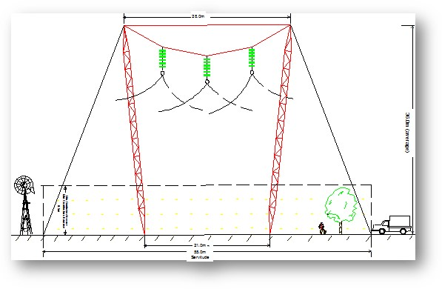
Figure 1: Cross Rope Tower
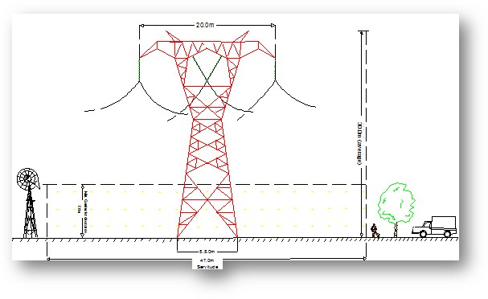
Figure 2: Self-Supporting Tower

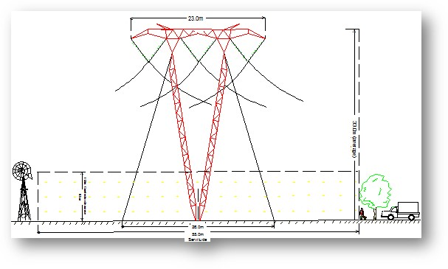
Figure 3: Guyed Vee Tower

A 55 m servitude (27.5 m on either side of the centre line) is required to accommodate the towers on which the overhead line will be strung. In forestry areas the servitude needs to be wider. The servitude is required to ensure safe construction, maintenance and operation of the line and Eskom will be entitled to unrestricted access. Where 400 kV power lines are constructed in parallel, a minimum separation distance of 55 m between centre points is required. Minimum vertical clearance distance between the ground and power line conductors is 8.1 m.

The minimum vertical clearance to any fixed structure that does not form part of the power line is 5.6 m. The minimum distance from a power line running parallel to a proclaimed public road is 90m from the centreline of the road servitude. The minimum safe distance required to the edge of a domestic house is 40 m from the centre of the power line (i.e. 27.5 m plus 12.5 m). The maximum crop height within the servitude is 4.3 m. The maximum operation height under the conductors is 2.0 m.

2.2 Construction Process
The construction process consists of the following phases:
- Contractor site establishment;
- Survey and pegging of tower positions;
- Access road negotiation and construction;
- Gate installation and vegetation clearing;
- Foundation excavation and installation;
- Tower assembly and erection;
- Conductor stringing and tensioning, and
- Servitude clean-up and rehabilitation.

2.3 Operation and Maintenance
Ongoing maintenance of the power lines will be required throughout its lifespan. Line inspections are usually undertaken once or twice per annum. This may be done via the access routes, or by helicopter. The Environmental Management Programme (EMP) specifies these operational and maintenance requirements.

Does the project form part of any of the Strategic Infrastructure Projects (SIPs) as described in the National Development Plan, 2011? | YES

If YES, please indicate which SIPs are applicable in Appendix 2. You are also required to provide confirmation of SIP applications from the relevant sector representative which must be attached in Appendix 2
Please indicate which sector the project falls under by crossing out the relevant block in the table below:

Table 1
Green economy + “Green” and energy-saving industries |  | Greenfield transformation to urban or industrial form (including mining)
Infrastructure – electricity (generation, transmission & distribution) | X | Biodiversity or sensitive area related activities
Oil and gas |  | Mining value chain
Biofuels |  | Potential of metal fabrication capital & transport equipment – arising from large public investments
Nuclear |  | Boat building
Basic services (local government) – electricity and electrification |  | Manufacturing – automotive products and components, and medium and heavy commercial vehicles
Basic services (local government) – area lighting |  | Manufacturing – plastics, pharmaceuticals and chemicals
Infrastructure – transport (ports, rail and road) |  | Manufacturing – clothing textiles, footwear and leather
Basic services (local government access roads) |  | Forestry, paper, pulp and furniture
Basic services (local government) – public transport |  | Business process servicing
Infrastructure – water (bulk and reticulation) |  | Advanced materials
Basic services (local government) – sanitation |  | Aerospace
Basic services (local government) – waste management |  | Basic services (local government) – education
Basic services (local government) water |  | Basic services (local government) – health
Agricultural value chain + agro-processing (linked to food security and food pricing imperatives) |  | Basic services (local government) - housing
Infrastructure – information and communication technology |  | Basic services (local government) security of tenure
Tourism + strengthening linkages between cultural industries and tourism |  | Other
Basic services (local government) – public open spaces and recreational facilities

Table 2
Does the listed activity/ies applied for form part of a larger project which is not a listed activity itself e.g. a road that is a listed activity that is needed to access a drilling site where the drilling does not constitute a listed activity. |  | NO
If indicated yes above, please provide a brief description on how the activity/ies relate to the larger project that forms part there of:

GENERAL information

Applicant name: | Eskom Holdings SOC Ltd
Registration number (if applicant is a company) | 2002/015527/30
Trading name (if any) | Eskom Holdings SOC Ltd
Responsible person name (If the applicant is a company): | Archibold Mogokonyane
Applicant/ Responsible person ID number: | 7011045082088
Responsible position, e.g. Director, CEO, etc.: | Programme Manager: Land Development
Physical address: | Megawatt Park, Maxwell Drive, Sunninghill, Johannesburg
Postal address: | P O Box 1091, Johannesburg,
Postal code: | 2000 | Cell: | 082 466 6022
Telephone: | 011 800 3778 | Fax: | 011 800 3917
E-mail: | MogokoA@eskom.co.za | BBBEE status | State Owned Company
Provincial Authority: | KwaZulu-Natal Department of Economic Development, Tourism and Environmental Affairs.
Contact person: | Ms Zama Mbanjwa
Postal address: | Private Bag x1048
Postal code: | 3900 | Cell: | 073 875 7763
Telephone: | 035 780 0314 | Fax:
E-mail: | zama.mbanjwa@edtea.gov.za
Local municipality | See Appendix 3
Contact person:
Postal address:
Postal code: |  | Cell:
Telephone: |  | Fax:
E-mail:

In instances where there is more than one local authority involved, please attach a list of those local authorities with their contact details as Appendix 3.

Landowner: | See Appendix 4
Contact person:
Postal address:
Postal code: |  | Cell:
Telephone: |  | Fax:
E-mail:
In instances where there is more than one landowner, please attach a list of those landowners with their contact details as Appendix 4. If the applicant is not the owner or person in control of the land, proof of notice to the landowner or person in control of the land on which the activity is to be undertaken must be submitted in Appendix 4.

Identified Competent Authority to consider the application: | Department of Environmental Affairs
Reason(s) in terms of S 24C of NEMA 1998 as amended | The activity is undertaken by a State Owned Company (Eskom Holdings SOC Ltd.)

Environmental Assessment Practitioner (eAP) information

EAP: | Terry Calmeyer
Professional affiliation/registration: | Certified Environmental Assessment Practitioner (Reg. 0067/05)
Contact person (if different from EAP):
Company: | MDT Environmental (Pty) Ltd
Physical address: | 1761 Tezula Estate, Uranium Street, Witkoppen ext 107, 2191
Postal address: | 1761 Tezula Estate, Uranium Street, Witkoppen ext 107, 2191
Postal code: | 2191 | Cell: | 082 455 1157
Telephone: | 011 465 2163 | Fax: | 086 242 3117
E-mail: | terry@mdte.co.za

If an EAP has not been appointed please ensure that an independent EAP is appointed as stipulated by Regulation 12 of GN R.982, dated December 2014, prior to the commencement of the process.
The declaration of independence and the Curriculum Vitae (indicating the experience with environmental impact assessment and the relevant application processes) of the EAP must also be submitted to the Department.

SITE description

Provide a detailed description of the site involved in the application.

Province | KwaZulu-Natal
District Municipality | uMkhanyakude, Zululand and uThungulu
Local Municipality | Jozini, Mfolozi, Mtabatuba, Nongoma, Mthonjaneni, Big Five Hlabisa and Ulundi local municipalities
Ward number(s) | See Appendix 5
Nearest town(s) | Mkuze and Hluhluwe
Farm name(s) and number(s) | See Appendix 5
Portion number(s) | See Appendix 5

SG 21 Digit Code(s)
(If there are more than 4, please attach a list with the rest of the codes as Appendix 5)
S | e | e |  | A | p | p | e | n | d | i | x |  | 5
1 |  |  | 2 |  |  | 3 |  |  |  |  |  | 4 |  |  |  |  |  | 5

Are there any other applications for Environmental Authorisation on the same property? |  | YES | NO
If YES, please indicate the following:
Competent Authority
Reference Number
Project Name
Please provide details of the steps taken to ascertain this information:

Landowners have been identified, notified and consulted. No applications for Environmental Authorisations on any of the potentially affected properties were raised.

Activities TO BE AUTHORISED

For an application for authorisation that involves more than one listed activity that, together, make up one development proposal, all the listed activities pertaining to this application must be indicated.

Detailed description of listed activities associated with the project
Listed activity as described in GN R 983 984 and 985 | Description of project activity that triggers listed activity
GN R. 983 (19) as amended by GN R. 327 (19): The infilling or depositing of any material of more than 10 cubic meters into, or the dredging, excavation, removal or moving of soil, sand, shells, shell grit, pebbles or rock of more than 10 cubic meters from – (i) a watercourse. | The upgrading or construction of access roads will require the infilling or depositing of material of more than 10 cubic meters into, or the dredging, excavation, removal or moving of soil, sand, shells, shell grit, pebbles or rock of more than 10 cubic meters from a watercourse.
GN R. 983 (24) as amended by GN R. 327 (24): The development of a road-  where no reserve exists where the road is wider than 8 metres. | Access roads for the construction and operation of the towers will be required. These will all be in the authorised corridors.
GN R. 983 (28) as amended by GN R. 327 (28) Institutional developments wherever such land was used for agriculture, game farming, equestrian purposes or afforestation after 1 April 1998, outside an urban area where the total land is bigger than 1 ha. | The construction of the power lines will require the use of some land that is currently being used for agriculture, game farming and/or afforestation.
GN R. 983 (56) as amended by GN R. 327 (56): The widening of a road by more than 6 meters, or the lengthening of a road by more than 1 kilometre- (i) where the existing road reserve is 13,5 meters; or (ii) where no reserve exists, where the existing road is wider than 8 meters; excluding where widening or lengthening occur inside and urban area. | Upgrading of access roads will require The widening of a road by more than 6 meters, or the lengthening of a road by more than 1 kilometre- where the existing road reserve is 13, 5 meters; or where no reserve exists, where the existing road is wider than 8 meters; outside of urban areas.
GN R 984 (9) as amended by GN R. 325 (9): The development of facilities or infrastructure for the transmission and distribution of electricity with a capacity of 275 kV or more, outside an urban area or industrial complex.  t. | The power lines are infrastructure that is part of the system for the transmission of 400 kV of electricity outside of urban areas and industrial complexes.
GN R. 985 (4) as amended by GN R. 324 (4): Development of a road wider than 4 m with a reserve less than 13, 5 metres. (d) In KwaZulu-Natal (iii) Community Conservation Areas; (v) Biodiversity Stewardship Programme Biodiversity Agreement areas; (vi) A protected area identified in terms of NEMPAA, excluding conservancies; (vii) Sites or areas identified in terms of an International Convention; (viii) Critical Biodiversity areas as identified in systemic biodiversity plans adopted by the competent authority or bioregional plans; (ix) Core areas in Biosphere Reserves; (x) Areas designated for conservation use in Spatial Development Frameworks adopted by competent authority or zoned for conservation purpose; (xi) Sensitive areas as identified in an environmental management framework as contemplated in Chapter 5 of the Act and as adopted by the competent authority; (xii) Outside urban areas (i) Areas within 10 kilometres from national parks or world heritage sites or 5 kilometres from any terrestrial protected area identified in terms of NEMPAA or from the core areas of a biosphere reserve. | Access roads will be constructed or upgraded. This will be located on a site outside of urban areas on a site not previously used for this purpose, and could be a Community Conservation Area, Biodiversity Stewardship Programme Biodiversity Agreement area, a protected area identified in terms of NEMPAA, a sites or area identified in terms of an International Convention, a Critical Biodiversity areas as identified in systemic biodiversity plans adopted by the competent authority or bioregional plans, a core areas in a Biosphere Reserves, an areas designated for conservation use in a Spatial Development Framework adopted by a competent authority or zoned for conservation purpose, a sensitive area as identified in an environmental management framework as contemplated in Chapter 5 of the Act and as adopted by the competent authority, within 10 kilometres from national parks or world heritage sites or 5 kilometres from any terrestrial protected area identified in terms of NEMPAA or from the core areas of a biosphere reserve. The exact details will be confirmed during the EIA.
GN R. 985 (12) as amended by GN R. 324 (12): Clearance of an area of 300 m2 or more of indigenous vegetation except where such clearance of indigenous vegetation is required for maintenance purposes undertaken in accordance with a maintenance plan. In (b) KwaZulu-Natal: (ii) community conservation areas; (iv) within any critically endangered or endangered ecosystem listed in terms of section 52 of the NEMBA or prior to the publication of such a list, within an areas that has been identified as critically endangered in the National Spatial Biodiversity Assessment 2004; (v) Critical biodiversity areas as identified is systemic biodiversity plans adopted by the competent authority or in bioregional plans; (vii) On land, where, at the time of the coming into effect of this Notice or thereafter such land was zoned open space, conservation or had an equivalent zoning; (viii) A protected area identified in terms of NEMPAA, excluding conservancies; (xi) Areas designated for conservation use in Spatial Development Frameworks adopted by competent authority or zoned for a conservation purpose; (xii) Sensitive areas as identified in an environmental management framework as contemplated in chapter 5 of the Act and as adopted by the competent authority. | The tower footprints will be cleared of vegetation. Some of these areas are in KwaZulu-Natal and in community conservation areas; within any critically endangered or endangered ecosystem listed in terms of section 52 of the NEMBA or prior to the publication of such a list, within an areas that has been identified as critically endangered in the National Spatial Biodiversity Assessment 2004; Critical biodiversity areas as identified is systemic biodiversity plans adopted by the competent authority or in bioregional plans; On land, where, at the time of the coming into effect of this Notice or thereafter such land was zoned open space, conservation or had an equivalent zoning; A protected area identified in terms of NEMPAA, excluding conservancies; Areas designated for conservation use in Spatial Development Frameworks adopted by competent authority or zoned for a conservation purpose; or Sensitive areas as identified in an environmental management framework as contemplated in chapter 5 of the Act and as adopted by the competent authority.

Please note that any authorisation that may result from this application will only cover activities specifically applied for. Co-ordinate points indicating the location of each listed activity must be provided with the relevant report (i.e. either BAR or EIR).

Please provide a project map indicating any sensitive areas (e.g. critical biodiversity area, World Heritage Site, etc.) overlaid by the study area in Appendix 6. A project schedule, indicating the different phases and timelines of the project, must be attached as Appendix 7.

public participation

Provide details of the public participation process proposed for the application as required by Regulation 41(2) of GN R .982, dated December 2014.

I&AP Database
Interested and Affected Parties (I&APs) have been invited to register on a stakeholder database. They have been categorised into sectors and a full record of their participation in the project, including comments submitted, will be recorded. There are currently approximately 1500 I&APs registered on the database. See a list of registered I&APs in Appendix 10.

Stakeholder Identification
Taking into account the legal requirements set out in the regulations (39 – 44), the following steps were undertaken to identify, notify and register I&APs:

An effort was made to ensure that individuals and/or organisations were identified from an institutional and geographic point of view. The KZN Department of Cooperative Governance and Traditional Affairs (COGTA) assisted the Public Participation Team in identifying stakeholders within the uMkhanyakude and Zululand Districts.

Although local councillors were identified within the study area, it is worth mentioning that the project was announced at the time when the country was approaching the South African Municipal Elections, 2016 (held on 03 August 2016) to elect councils for all districts, metropolitan and local municipalities. By implication, all councillors (including Mayors) originally identified and included on database have been replaced by newly elected officials.

I&APs identified and notified included the following:
- National and Provincial government departments:
  - Department of Water and Sanitation,
  - Department of Agriculture, Forestry and Fisheries,
  - Department of Local Government and Traditional Affairs,
  - AMAFA/Heritage KwaZulu-Natal,
  - Ezemvelo KZN Wildlife,
  - Department of Agriculture and Rural Development (DARD),
  - KZN Department of Economic Development, Tourism and Environmental Affairs (DEDTEA),
  - KZN Department of Cooperative Governance and Traditional Affairs (COGTA),
- Organs of state which have jurisdiction in respect of the activity to which the application relates:
  - Eskom Holdings SOC Limited
- District Municipalities:
  - uMkhanyakude District Municipality
  - Zululand District Municipality
  - uThugulu District Municipality
- The Local Municipalities:
  - The Big Five Hlabisa Local Municipality
  - Jozini Local Municipality
  - Nongoma Local Municipality
  - Ulundi Local Municipality
  - Mthonjaneni Local Municipality
  - Mfolozi Local Municipality
  - Mtubatuba Local Municipality
- Landowners/Land Occupiers.
  - Private Landowners
  - Game Reserves and Tourism Establishment Operators
  - Community Trusts
- Traditional Councils

A GIS map has been developed with all properties shown and shaded in to notify or involve the owners in the process (Appendix 10). This will give a visual representation of the extent of landowner consultation.

Placing an advertisement in one local newspaper or Gazette
Newspaper advertisements have been drafted, translated into Zulu and placed in the papers listed in Table 7.1.

Table 7.1: Newspapers where advertisements have been published
Newspaper | Language | Geographic area covered | Date of publication
Mercury Regional newspaper | English | Mkhuze, Pongola, Paulpietersburg, Duma and Vryheid | 11 August 2016
Excelsior News | English | Piet Retief | 11 August 2016
Isolezwe | Zulu | Mkhuze, Pongola, Paulpietersburg, Duma and Vryheid | 11 August 2016

A second round of newspaper advertisements will be place in the same newspapers to announce the availability of the Draft Scoping Report for comment, and to invite I&APs to the second round of Key Stakeholder and Authorities Meetings.

17 onsite notices have been erected, at the locations indicated on Figure 7.1. Notices comply with GN 326 Regulation 41 (2), (3) and (4). Additional notices will be erected at Iphiva sites 8 to 13 during the public comment period.
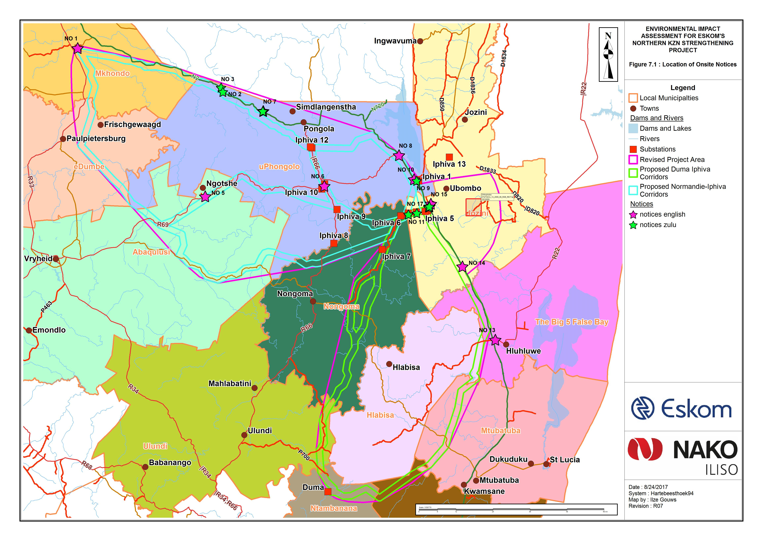
Figure 7.1: Onsite Notices

Background Information Document
A 6 page x A4 Background Information Document has been compiled and translated into Zulu and distributed with the notification letters. A total of 1500 copies were printed of which 1200 was Zulu and 300 were English. Additional copies were made available at the first round of key stakeholder and authorities’ meetings and focus group meetings (See Appendix 10).

Key Stakeholder and Authorities Meetings
The first round of Key Stakeholder and Authorities’ meetings took place in September 2016 (Table 7.2).

Table 7.2: Venues for Key Stakeholder Meetings
AREA | DATE | VENUES | TIME | ATTENDEES
Piet Retief | 05 Sept 2016 | Piet Retief Country Club West End Street, Piet Retief | 10h00 – 12h30 | 9
Pongola | 06 Sept 2016 | Pongola Country Lodge 14 Jan Mielie Street Pongola | 10h00 – 12h30 | 13
Mkhuze | 07 Sept 2016 | Ghost Mountain Inn  Fish Eagle Road, Mkhuze | 10h00 – 12h30 | 14
Hluhluwe | 08 Sept 2016 | Protea Hotel 104 Main Road, Hluhluwe | 10h00 – 12h30 | 9

Focus Group Meetings
A meeting with Ezemvelo KZN Wildlife took place in Pietermaritzburg on 9 September 2016. Minutes have been compiled and distributed.

Meetings with Traditional Councils
31 Traditional Councils within the uMkhanyakude and Zululand Districts that could be affected by the project have been identified. The meetings that have taken place are presented in Table 7.3.

Table 7.3 : Focus Group Meetings with Traditional Councils that have taken place
No | Date | Traditional Council | Venue
1 | 12 Sept 2016 | Qwabe/Makhasa | Tribal Court (Hluhluwe)
2 | 13 Sept 2016 | Nibela | Tribal Court (Hluhluwe)
3 | 14 Sept 2016 | Abakwa Hlabisa | Tribal Court (Hlabisa)
4 | 14 Sept 2016 | Mdletshe | Tribal Court (Hlabisa)
5 | 15 Sept 2016 | Mpembeni | Tribal Court (Hlabisa)
6 | 20 Sept 2016 | Myeni/Ntsinde | Tribal Court (Obonjeni)
7 | 20 Sept2016 | Myeni/Ngwenya | Tribal Court (Mkhuze)
8 | 21 Sept 2016 | Ndlangamandla | Tribal Court (Pongola)
9 | 22 Sept 2016 | Sibiya | Tribal Court (Pongola)
10 | 23 Sept 2016 | Msibi | Tribal Court (Emgulatshani)
11 | 26 Sept 2016 | Simelane | Tribal Court (Pongola)
12 | 26 Sept 2016 | Buyelekhaya Community Trust | Tribal Court (Pongola)
13 | 27 Sept 2016 | Gumbi | Tribal Court (Pongola)
14 | 28 Sept 2016 | Emgazini | Tribal Court (Pongola)
15 | 28 Sept 2016 | Klwana | Tribal Court (Louwsburg)
16 | 29 Sept 2016 | Ntshangase | Tribal Court (Pongola)
17 | 03 Oct 2016 | Mavuso | Tribal Court (Piet Retief)
18 | 04 Oct 2016 | Msiyane | Tribal Court (Langkraans)
19 | 05 Oct 2016 | Empangisweni | Tribal Court (Gluckstadt)
20 | 06 Oct 2016 | Khambi | Tribal Court (Vryheid)
21 | 07 Oct 2016 | Emathongeni | Tribal Court (Swart Umfolozi)
22 | 10 Oct 2016 | Hlahlindlela | Tribal Court (Nquthu)
23 | 11 Oct 2016 | Othaka | Tribal Court (Emondlo)
24 | 12 Oct 2016 | Usuthu | Tribal Court (Nongoma)
25 | 13 Oct 2016 | Mandlakazi | Tribal Court (Nongoma)
26 | 14 Oct 2016 | Matheni | Tribal Court (Nongoma)
27 | 17 Oct 2016 | Bhovungane | Tribal Court (Paulpietersburg)
28 | 18 Oct 2016 | Ndlela | Tribal Court (Paulpietersburg)
29 | 19 Oct 2016 | Dlamini | Tribal Court (Paulpietersburg)
30 | 20 Oct 2016 | Mthethwa | Tribal Court (Paulpietersburg)
31 | 21 Oct 2016 | Mpukunyoni/Mkhwanazi | Tribal Court (Mtubatuba)

These meetings were conducted in Zulu.

Comments and Responses Report
The issues raised in meetings, telephone calls or emails have been recorded in a Comments and Responses Report (CRR) that will be updated as the project progresses. A copy of the Comments and Responses Report will be sent to stakeholders that submit comments during the public comment periods for the draft reports in order for them to confirm that their issues have been accurately captured and understood (See Appendix 10).

Draft Report Comment Periods
The 2014 EIA Regulations require a 30 day comment period for all draft reports prior to submission to the competent authority. The first comment period is for the draft Scoping Report. Registered I&APs will be notified by e-mail (or fax, post of phone if they do not have an e-mail address), of the availability of the draft documents for comment. The notification letter will include comments sheets for I&APs to complete to facilitate the efficient collation of comments. Text messages will be sent by Short Message Service (SMS) to all registered I&APs to alert them to the comment period.

Hard copies of the draft documents will be left at four public places in the study area, as indicated in Table 7.4. Pdf versions of the documents will be uploaded to the NAKO ILISO and/or Eskom websites. Provision has been made to cut 20 CDs of each of the sets of draft reports. These will be available at key stakeholder and authorities and focus group meetings, or posted to I&APs on request.

Table 7.4: Venues where copies of draft documents will be left
Area | Venue | Address | Contact Details
Piet Retief | Piet Retief Public Library | Piet Retief, 2380 | Tel: 017 826 8153
Pongola | Pongola Public Library | 61 Martin St, Pongola, 3170 | Tel: 034 413 1540
Mkhuze | Ghost Mountain Inn | Fish Eagle Street, Mkuze | Tel: 035 573 1025
Hluhluwe | Hluhluwe Public Library | 163 Zebra Street, Hluhluwe | Tel: 035 562 0040

All comments received during the Draft Scoping Report Comment Period will be added to Version 2 of the CRR for inclusion in the Final Scoping Report.

NAKO ILISO will provide feedback to stakeholders throughout the process. I&APs and the public will be informed of the availability of the draft EIA report (through written notification to registered stakeholders), as well as of the authorities’ decision and the appeal process in respect of the various applications (through newspaper advertisement and written notification to all registered stakeholders).

OTHER AUTHORISATIONS REQUIRED

LEGISLATION | AUTHORISATION REQUIRED |  | APPLICATION SUBMITTED
SEMAs
National Environmental Management: Air Quality Act | YES | NO | YES | NO
National Environmental Management: Biodiversity Act | YES | NO | YES | NO
National Environmental Management: Integrated Coastal Management Act | YES | NO | YES | NO
National Environmental Management: Protected Areas Act | YES | NO | YES | NO
National Environmental Management: Waste Act | YES | NO | YES | NO
National legislation
Mineral Petroleum Development Resources Act | YES | NO | YES | NO
National Water Act | YES | NO | YES | NO
National Heritage Resources Act | YES | NO | YES | NO
Others: Please specify | YES | NO | YES | NO

Authorisations in terms of the NWA and NHRA are required. Neither has been submitted yet.

If authorisation is necessary in terms of the National Environmental Management: Waste Act, please contact the Department for guidance on the Integrated Permitting System.

List of appendices
 |  | SUBMITTED
Appendix 1 | Proof of Payment/Motivation of Exclusion | YES | NO
Appendix 2 | Strategic Infrastructure Projects | YES | NO
Appendix 3 | List of Local Municipalities (with contact details) | YES | NO
Appendix 4 | List of land owners (with contact details) and proof of notification of land owners. | YES | NO
Appendix 5 | List of SG IDs | YES | NO
Appendix 6 | Project map | YES | NO
Appendix 7 | Project schedule | YES | NO
Appendix 8 | Public Participation Process | YES | NO
Appendix 9 | Declaration of Applicant | YES | NO
Appendix 10 | Curriculum Vitae Declaration of EAP | YES | NO

APPENDIX 1

PROOF OF PAYMENT/ MOTIVATION FOR EXCLUSION
The applicant is Eskom Holdings SOC Ltd (Eskom). Eskom is a state owned entity and is therefore exempt from paying application fees.
APPENDIX 2

STRATEGIC INFRASTRUCTURE PROJECTS

SIP 1: Unlocking the northern mineral belt with Waterberg as the catalyst
- Unlock mineral resources
- Rail, water pipelines, energy generation and transmission infrastructure
- Thousands of direct jobs across the areas unlocked
- Urban development in Waterberg - first major post-apartheid new urban centre will be a “green” development project
- Rail capacity to Mpumalanga and Richards Bay
- Shift from road to rail in Mpumalanga
- Logistics corridor to connect Mpumalanga and Gauteng.

SIP 2: Durban-Free State-Gauteng logistics and industrial corridor
- Strengthen the logistics and transport corridor between SA’s main industrial hubs
- Improve access to Durban’s export and import facilities
- Integrate Free State Industrial Strategy activities into the corridor
- New port in Durban
- Aerotropolis around OR Tambo International Airport.

SIP 3: South-Eastern node & corridor development
- New dam at Mzimvubu with irrigation systems
- N2-Wild Coast Highway which improves access into KwaZulu-Natal and national supply chains
- Strengthen economic development in Port Elizabeth through a manganese rail capacity from Northern Cape
- A manganese sinter (Northern Cape) and smelter (Eastern Cape)
- Possible Mthombo refinery (Coega) and transhipment hub at Ngqura and port and rail upgrades to improve industrial capacity and performance of the automotive sector.

SIP 4: Unlocking the economic opportunities in North West Province
- Acceleration of investments in road, rail, bulk water, water treatment and transmission infrastructure
- Enabling reliable supply and basic service delivery
- Facilitate development of mining, agricultural activities and tourism opportunities
- Open up beneficiation opportunities in North West Province.

SIP 5: Saldanha-Northern Cape development corridor
- Integrated rail and port expansion
- Back-of-port industrial capacity (including an IDZ)
- Strengthening maritime support capacity for oil and gas along African West Coast
- Expansion of iron ore mining production and beneficiation.

SIP 6: Integrated municipal infrastructure project
Develop national capacity to assist the 23 least resourced districts (19 million people) to address all the maintenance backlogs and upgrades required in water, electricity and sanitation bulk infrastructure. The road maintenance programme will enhance service delivery capacity thereby impacting positively on the population.

SIP 7: Integrated urban space and public transport programme
Coordinate planning and implementation of public transport, human settlement, economic and social infrastructure and location decisions into sustainable urban settlements connected by densified transport corridors. This will focus on the 12 largest urban centres of the country, including all the metros in South Africa. Significant work is underway on urban transport integration.

SIP 8: Green energy in support of the South African economy
Support sustainable green energy initiatives on a national scale through a diverse range of clean energy options as envisaged in the Integrated Resource Plan (IRP2010) and support bio-fuel production facilities.

Indicate capacity in MW:
SIP 9: Electricity generation to support socioeconomic development
Accelerate the construction of new electricity generation capacity in accordance with the IRP2010 to meet the needs of the economy and address historical imbalances. Monitor implementation of major projects such as new power stations: Medupi, Kusile and Ingula.

Indicate capacity in MW:
SIP 10: Electricity transmission and distribution for all  Expand the transmission and distribution network to address historical imbalances, provide access to electricity for all and support economic development.  Align the 10-year transmission plan, the services backlog, the national broadband roll-out and the freight rail line development to leverage off regulatory approvals, supply chain and project development capacity. | X
SIP 11: Agri-logistics and rural infrastructure
Improve investment in agricultural and rural infrastructure that supports expansion of production and employment, small-scale farming and rural development, including facilities for storage (silos, fresh-produce facilities, packing houses); transport links to main networks (rural roads, branch train-line, ports), fencing of farms, irrigation schemes to poor areas, improved R&D on rural issues (including expansion of agricultural colleges), processing facilities (abattoirs, dairy infrastructure), aquaculture incubation schemes and rural tourism infrastructure.

SIP 12: Revitalisation of public hospitals and other health facilities
Build and refurbish hospitals, other public health facilities and revamp 122 nursing colleges. Extensive capital expenditure to prepare the public healthcare system to meet the requirements of the National Health Insurance (NHI) system. The SIP contains major builds for 6 hospitals.

SIP 13: National school build programme
A national school build programme driven by uniformity in planning, procurement, contract management and provision of basic services. Replace inappropriate school structures and address basic service backlog and provision of basic services under the Accelerated School Infrastructure Delivery Initiative (ASIDI). In addition, address national backlogs in classrooms, libraries, computer labs and admin buildings. Improving the learning environment will strengthen outcomes especially in rural schools, as well as reduce overcrowding.

SIP 14: Higher education infrastructure
Infrastructure development for higher education, focusing on lecture rooms, student accommodation, libraries and laboratories, as well as ICT connectivity. Development of university towns with a combination of facilities from residence, retail to recreation and transport. Potential to ensure shared infrastructure such as libraries by universities, FETs and other educational institutions. Two new universities will be built - in Northern Cape and Mpumalanga.

SIP 15: Expanding access to communication technology
Provide for broadband coverage to all households by 2020 by establishing core Points of Presence (POPs) in district municipalities, extend new Infraco fibre networks across provinces linking districts, establish POPs and fibre connectivity at local level, and further penetrate the network into deep rural areas.
While the private sector will invest in ICT infrastructure for urban and corporate networks, government will co-invest for township and rural access, as well as for e-government, school and health connectivity.
The school roll-out focus is initially on the 125 Dinaledi (science and maths-focussed) schools and 1525 district schools. Part of digital access to all South Africans includes TV migration nationally from analogue to digital broadcasting.

SIP 16: SKA & Meerkat
SKA is a global mega-science project, building an advanced radio-telescope facility linked to research infrastructure and high-speed ICT capacity and provides an opportunity for Africa and South Africa to contribute towards global advanced science projects.

SIP 17: Regional integration for African cooperation and development
Participate in mutually beneficial infrastructure projects to unlock long-term socio-economic benefits by partnering with fast growing African economies with projected growth ranging between 3% and 10%.
The projects involving transport, water and energy also provide competitively-priced, diversified, short and medium to long-term options for the South African economy where, for example, electricity transmission in Mozambique (Cesul) could assist in providing cheap, clean power in the short-term whilst Grand Inga in the DRC is long-term.
All these projects complement the Free Trade Area (FTA) discussions to create a market of 600 million people in South, Central and East Africa.

SIP 18: Water and sanitation infrastructure
A 10-year plan to address the estimated backlog of adequate water to supply 1.4m households and 2.1m households to basic sanitation.
The project will involve provision of sustainable supply of water to meet social needs and support economic growth. Projects will provide for new infrastructure, rehabilitation and upgrading of existing infrastructure, as well as improve management of water infrastructure.

APPENDIX 3 (if applicable)

List of local municipalities

Local municipality | Big 5 Hlabisa Local Municipality
Contact person:
Postal address: | P.O Box 89, Hluhluwe
Postal code: | 3960 | Cell:
Telephone: | 035 562 0040 | Fax: | 035 562 0988
E-mail:

Local municipality | Jozini Local Municipality
Contact person:
Postal address: | Private Bag X 028, Jozini
Postal code: | 3969 | Cell:
Telephone: | 035 572 1292 | Fax: | 035 572 1266
E-mail: | info@jozini.gov.za

Local municipality | Mfolozi Local Municipality
Contact person: | Municipal Manager: Mr K.E Gumede
Postal address: | P.0. Box 96
Postal code: | 3915 | Cell:
Telephone: | 035 580 1421 | Fax: | 035 580 1141
E-mail:

Local municipality | Mthonjaneni Local Municipality
Contact person: | Municipal Manager: RP Mnguni
Postal address: | P.O Box 11, Memoth, Kwazulu-natal
Postal code: | 3835 | Cell:
Telephone: | 035 450 2082 | Fax: | 035 450 2056
E-mail: | meltc@mweb.co.za

Local municipality | Mtubatuba Local Municipality
Contact person: | Municipal Manager: Mr M Ntuli
Postal address:
Postal code: |  | Cell:
Telephone: |  | Fax:
E-mail: | mscc@mtubatuba.com

Local municipality | Nongoma Local Municipality
Contact person: | Municipal Manager: Mr BE Ntanzi
Postal address:
Postal code: | 035 831 7543 | Cell:
Telephone: |  | Fax:
E-mail: | ntanzib@nongoma.org.za

Local municipality | Ulundi Local Municipality
Contact person: | Municipal Manager: Princess SA Buthelezi
Postal address:
Postal code: |  | Cell:
Telephone: | 035 874 5810 | Fax:
E-mail: | sabuthelezi@ulundi.gov.za

APPENDIX 4

list of land owners

proof of notification of land owners

Landowner: | Alfred Barrie Trust Trustees
Contact person:
Postal address:
Postal code: |  | Cell: | 082 559 8740
Telephone: |  | Fax:
E-mail: | jdom@yebo.co.za

Landowner: | CH Badenhorst Trust-Trustees
Contact person: | Dirk Botha
Postal address:
Postal code: |  | Cell: | 082 857 2888
Telephone: |  | Fax:
E-mail: | finance@badenhorstbdy.co.za

Landowner: | Charl Senekal Suiker Trust
Contact person: | Mr Charl Senekal
Postal address:
Postal code: |  | Cell: | 082 555 1961
Telephone: |  | Fax:
E-mail: | sensugar@vodamail.co.za

Landowner: | Chick’s Lodge CC
Contact person: | Christine Ballantyne
Postal address:
Postal code: |  | Cell: | 082 874 9069
Telephone: |  | Fax:
E-mail: | info@chicks.co.za

Landowner: | Flip Raath Trust-Trustees
Contact person: | Arno Raath
Postal address:
Postal code: |  | Cell: | 082 372 4639
Telephone: |  | Fax:
E-mail: | raathk@gmail.com

Landowner: | Mark Channels (Pty) Ltd
Contact person: | Pierre Reddinger
Postal address:
Postal code: |  | Cell: | 083 300 0498
Telephone: |  | Fax:
E-mail: | pierre@chennellsfarms.com

Landowner: | Mark Channels (Pty) Ltd
Contact person: | Bester Scheepers
Postal address:
Postal code: |  | Cell: | 072 773 1827
Telephone: |  | Fax:
E-mail: | bester@chennellsfarms.com

Landowner: | Zululand Rhino Reserve
Contact person: | Karen Holmes
Postal address: | P O Box 74, Mkuze
Postal code: | 3965 | Cell: | 0828031026
Telephone: |  | Fax:
E-mail: | karen@zululandrhinoreserve.co.za

Landowner: | SANRAL
Contact person: | Mpati Makoa
Postal address: | 48 Tambotie Avenue, Val de Grace, Pretoria
Postal code: | 0001 | Cell: | 083 387 6620
Telephone: | 012 844 8000/13 | Fax:
E-mail: | makoam@nra.co.za

Landowner: | Thanda Group (Pty) Ltd
Contact person: | Warren Beets
Postal address:
Postal code: |  | Cell: | 083 203 0304
Telephone: |  | Fax:
E-mail: | pierre@thanda.co.za/research @thanda.co.za

Landowner: | Ingonyama Trust Board
Contact person: | Thandeka Ngema
Postal address: | PO Box 601, Pietermaritzburg
Postal code: | 3200 | Cell:
Telephone: | 033 846 9900 | Fax:
E-mail: | pa2ceo@ingoyamatrust.org.za

Landowner: | Sibuyele Ekhaya Communal Property Trust Trustees
Contact person: | Nozipho Mkize
Postal address:
Postal code: |  | Cell: | 082 078 6303
Telephone: | 081 743 0688 | Fax:
E-mail: | sibuyelekhaya.cpt@gmail.com

APPENDIX 5 (IF APPLICABLE)

lIST OF SGIDS

APPENDIX 6

SESITIVITY map
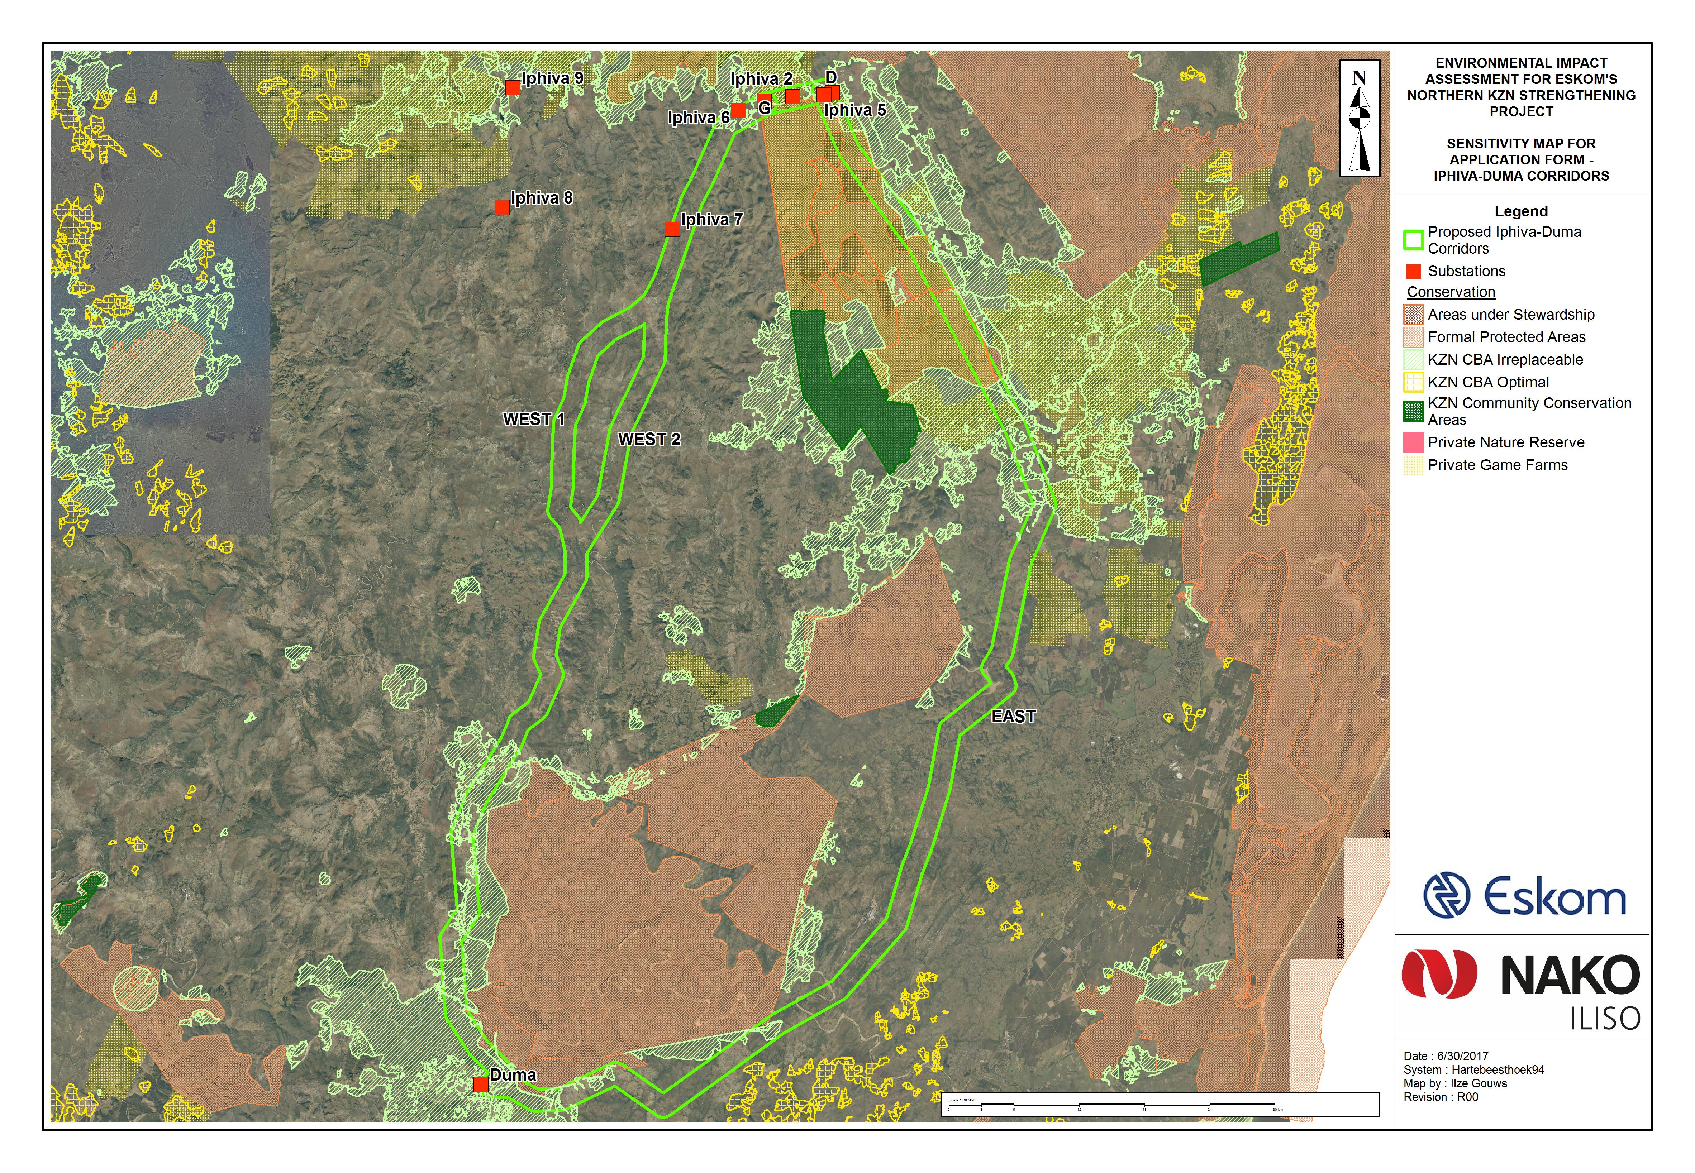

APPENDIX 7

project schedule

Phase | Timeframe
Environmental Impact Assessment | Current to 18 June 2017
Pre-construction planning (detail designs) | August 2021 to July 2023
Construction | September 2023 to July 2026
Operation | July 2026 to
De-commissioning

APPENDIX 8

Declaration of the applicant

I, , declare that I -

- am, or represent, the applicant in this application;
- have appointed / will appoint (delete that which is not applicable) an environmental assessment practitioner to act as the independent environmental assessment practitioner for this application / will obtain exemption from the requirement to obtain an environmental assessment practitioner;
- will provide the environmental assessment practitioner and the competent authority with access to all information at my disposal that is relevant to the application;
- will be responsible for the costs incurred in complying with the Regulations, including but not limited to –
- costs incurred in connection with the appointment of the environmental assessment practitioner or any person contracted by the environmental assessment practitioner;
- costs incurred in respect of the undertaking of any process required in terms of the Regulations;
- costs in respect of any fee prescribed by the Minister or MEC in respect of the Regulations;
- costs in respect of specialist reviews, if the competent authority decides to recover costs; and
- the provision of security to ensure compliance with conditions attached to an environmental authorisation, should it be required by the competent authority;
- will ensure that the environmental assessment practitioner is competent to comply with the requirements of the Regulations and will take reasonable steps to verify that the EAP
- know the Act and the regulations, and how they apply to the proposed development
- know any applicable guidelines
- perform the work objectively, even if the findings do not favour the applicant
- disclose all information which is important to the application and the proposed development
- have expertise in conducting environmental impact assessments
- complies with the Regulations
- will inform all registered interested and affected parties of any suspension of the application as well as of any decisions taken by the competent authority in this regard;
- am responsible for complying with the conditions of any environmental authorisation issued by the competent authority;
- hereby indemnify the Government of the Republic, the competent authority and all its officers, agents and employees, from any liability arising out of the content of any report, any procedure or any action which the applicant or environmental assessment practitioner is responsible for in terms of these Regulations;
- will not hold the competent authority responsible for any costs that may be incurred by the applicant in proceeding with an activity prior to obtaining an environmental authorisation or prior to an appeal being decided in terms of these Regulations;
- will perform all other obligations as expected from an applicant in terms of the Regulations;
- all the particulars furnished by me in this form are true and correct; and
- I realise that a false declaration is an offence in terms of regulation 48 and is punishable in terms of section 24F of the Act.

Signature of the applicant/ Signature on behalf of the applicant:

Name of company (if applicable):

Date:

APPENDIX 9

Declaration of the EAP

Terry Calmeyer
I, , declare that –

General declaration:

- I act as the independent environmental practitioner in this application
- I will perform the work relating to the application in an objective manner, even if this results in views and findings that are not favourable to the applicant
- I declare that there are no circumstances that may compromise my objectivity in performing such work;
- I have expertise in conducting environmental impact assessments, including knowledge of the Act, Regulations and any guidelines that have relevance to the proposed activity;
- I will comply with the Act, Regulations and all other applicable legislation;
- I will take into account, to the extent possible, the matters listed in regulation 8 of the Regulations when preparing the application and any report relating to the application;
- I have no, and will not engage in, conflicting interests in the undertaking of the activity;
- I undertake to disclose to the applicant and the competent authority all material information in my possession that reasonably has or may have the potential of influencing - any decision to be taken with respect to the application by the competent authority; and - the objectivity of any report, plan or document to be prepared by myself for submission to the competent authority;
- I will ensure that information containing all relevant facts in respect of the application is distributed or made available to interested and affected parties and the public and that participation by interested and affected parties is facilitated in such a manner that all interested and affected parties will be provided with a reasonable opportunity to participate and to provide comments on documents that are produced to support the application;
- I will ensure that the comments of all interested and affected parties are considered and recorded in reports that are submitted to the competent authority in respect of the application, provided that comments that are made by interested and affected parties in respect of a final report that will be submitted to the competent authority may be attached to the report without further amendment to the report;
- I will keep a register of all interested and affected parties that participated in a public participation process; and
- I will provide the competent authority with access to all information at my disposal regarding the application, whether such information is favourable to the applicant or not
- all the particulars furnished by me in this form are true and correct;
- will perform all other obligations as expected from an environmental assessment practitioner in terms of the Regulations; and
- I realise that a false declaration is an offence in terms of regulation 48 of the Regulations and is punishable in terms of section 24F of the Act.

Disclosure of Vested Interest (delete whichever is not applicable)

- I do not have and will not have any vested interest (either business, financial, personal or other) in the proposed activity proceeding other than remuneration for work performed in terms of the Regulations;

- I have a vested interest in the proposed activity proceeding, such vested interest being:

Signature of the environmental assessment practitioner:

MDT Environmental (Pty) Ltd
Name of company:

Date:

APPENDIX 10:
PUBLIC PARTICIPATION

- Public Participation Map
- I&AP Database
- Newspaper Advertisements
- Notifications and Invitation Letters
- Background Information Document and I &AP Registration Form
- Minutes of Key Stakeholder and Authorities Meetings
- Focus Group Meetings
- Traditional Council Meetings
- Comments and Responses Report

If this is signed on behalf of the applicant, proof of such authority from the applicant must be attached.
If exemption is obtained from appointing an EAP, the responsibilities of an EAP will automatically apply to the person conducting the environmental impact assessment in terms of the Regulations.
Only original signatures will be accepted. No scanned, copied or faxed signatures will be accepted.
If the applicant is a juristic person, a signature on behalf of the applicant is required as well as proof of such authority. An EAP may not sign on behalf of an applicant.

